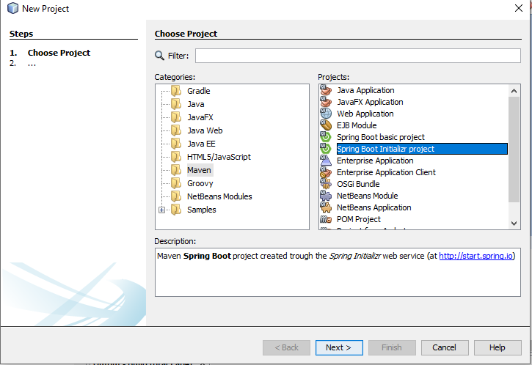

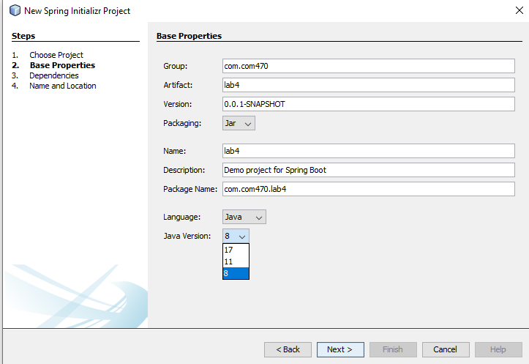

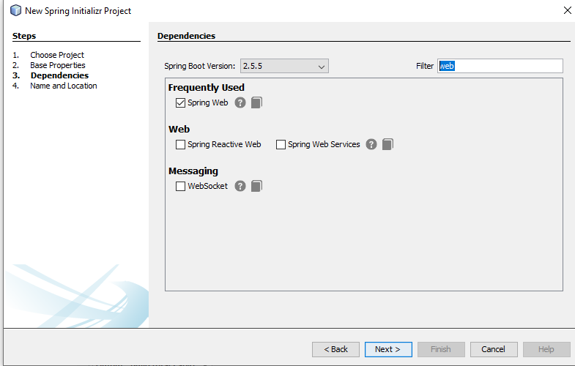

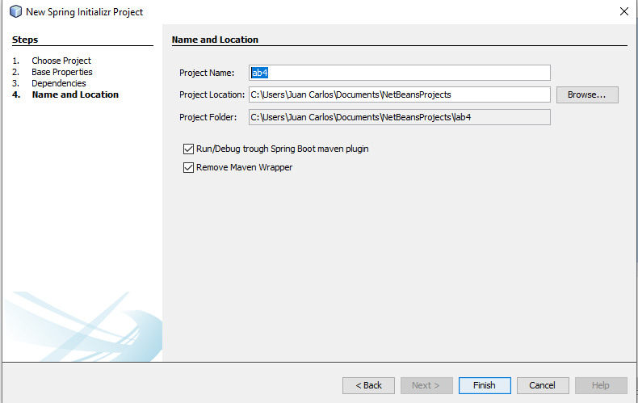

Editan el POM

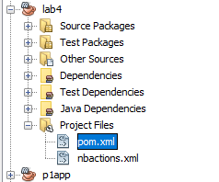

DESDE <dependencies> LO REEMPLAZAN TODO

<dependencies>

<dependency>

<groupId>org.springframework.boot</groupId>

<artifactId>spring-boot-starter-thymeleaf</artifactId>

</dependency>

<dependency>

<groupId>org.springframework.boot</groupId>

<artifactId>spring-boot-devtools</artifactId>

<optional>true</optional>

</dependency>

<dependency>

<groupId>junit</groupId>

<artifactId>junit</artifactId>

<version>4.12</version>

<scope>test</scope>

</dependency>

<dependency>

<groupId>org.hamcrest</groupId>

<artifactId>hamcrest-core</artifactId>

<version>1.3</version>

<scope>test</scope>

</dependency>

<dependency>

<groupId>org.springframework.boot</groupId>

<artifactId>spring-boot-starter-web</artifactId>

</dependency>

<dependency>

<groupId>org.seleniumhq.selenium</groupId>

<artifactId>selenium-api</artifactId>

<version>2.53.1</version>

<scope>test</scope>

<type>jar</type>

</dependency>

<dependency>

<groupId>org.seleniumhq.selenium</groupId>

<artifactId>selenium-chrome-driver</artifactId>

<version>2.53.1</version>

<scope>test</scope>

<type>jar</type>

</dependency>

<!-- <dependency>

<groupId>org.testng</groupId>

<artifactId>testng</artifactId>

<version>6.14.3</version>

<scope>test</scope>

<type>jar</type>

</dependency> -->

<dependency>

<groupId>org.springframework.boot</groupId>

<artifactId>spring-boot-test</artifactId>

<version>2.2.6.RELEASE</version>

<scope>test</scope>

<type>jar</type>

</dependency>

</dependencies>

<properties>

<project.build.sourceEncoding>UTF-8</project.build.sourceEncoding>

<java.version>1.8</java.version>

<thymeleaf.version>3.0.2.RELEASE</thymeleaf.version>

<thymeleaf-layout-dialect.version>2.1.1</thymeleaf-layout-dialect.version>

</properties>

<build>

<plugins>

<plugin>

<groupId>org.springframework.boot</groupId>

<artifactId>spring-boot-maven-plugin</artifactId>

</plugin>

<plugin>

<groupId>org.jacoco</groupId>

<artifactId>jacoco-maven-plugin</artifactId>

<version>0.7.7.201606060606</version>

<executions>

<execution>

<goals>

<goal>prepare-agent</goal>

</goals>

</execution>

<execution>

<id>report</id>

<phase>prepare-package</phase>

<goals>

<goal>report</goal>

</goals>

</execution>

</executions>

</plugin>

</plugins>

</build>

</project>

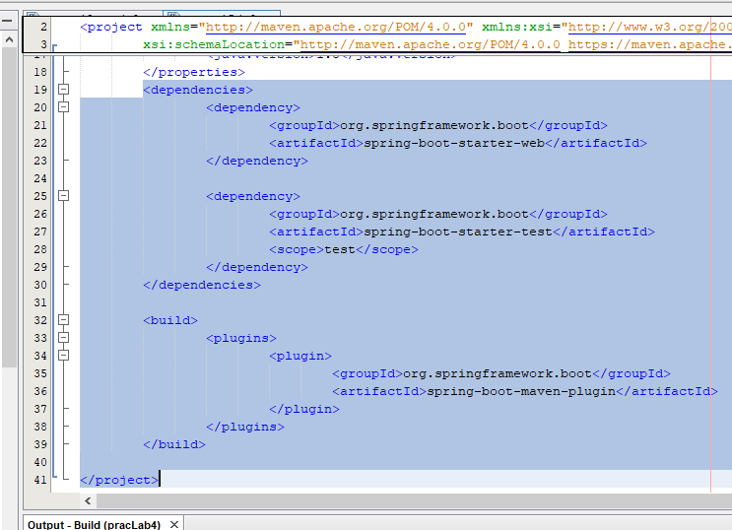

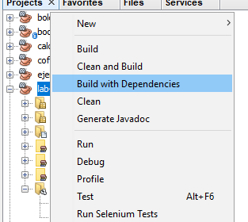

Inicialmente borran en test, para crearlo manualmente

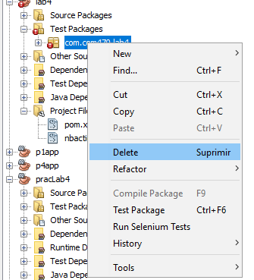

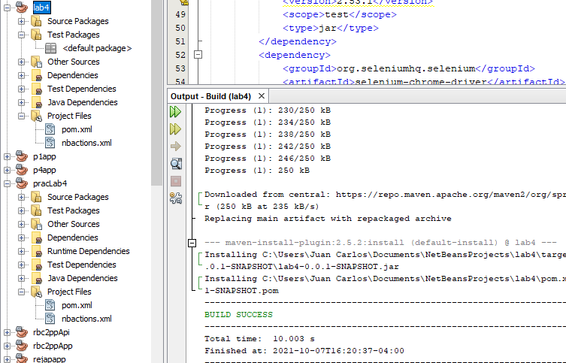

Crear 3 paquetes: controller, model y service

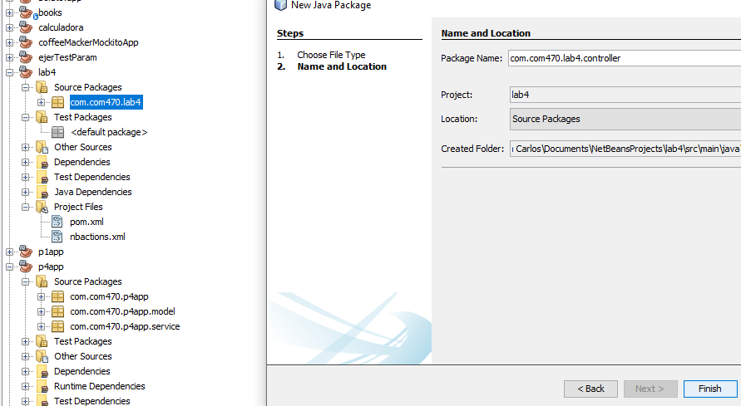

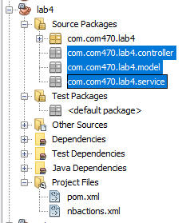

En el controller

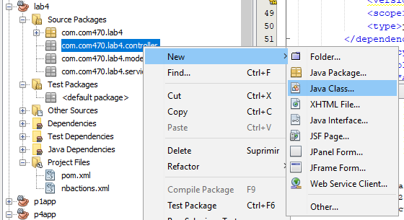

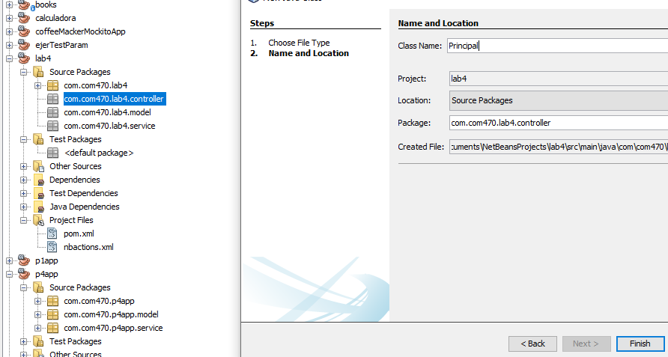

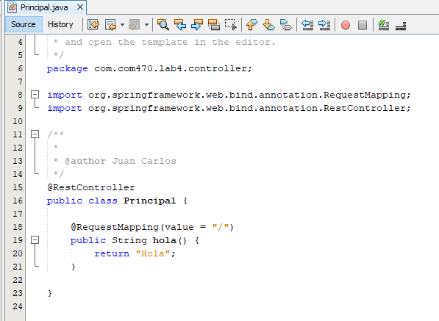

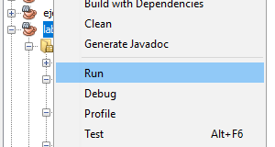

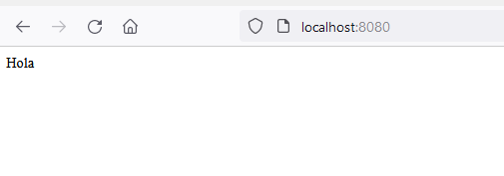

En el model

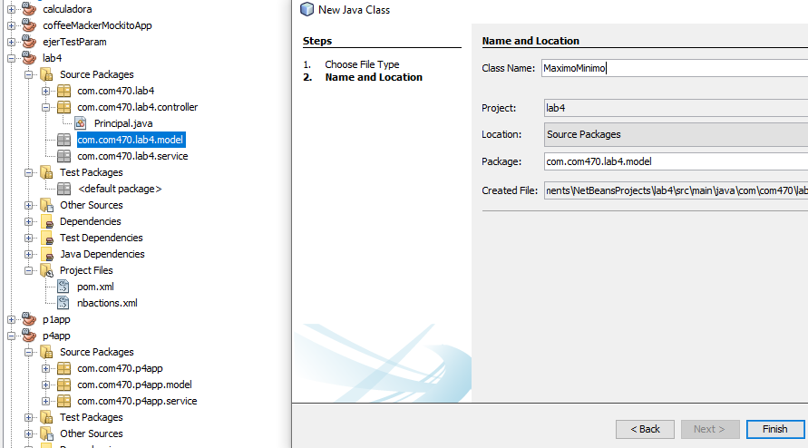

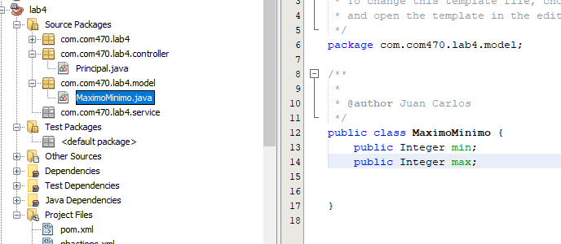

SHIFT + ALT + INSERT

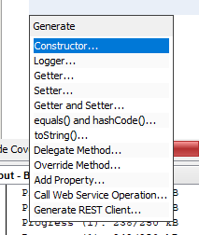

CON Y SIN PARAMETROS

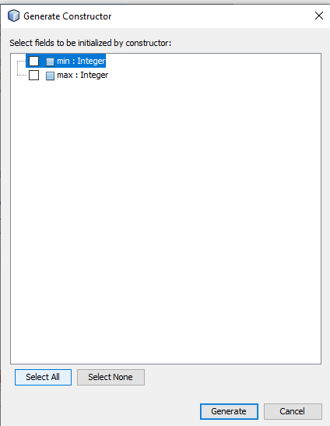

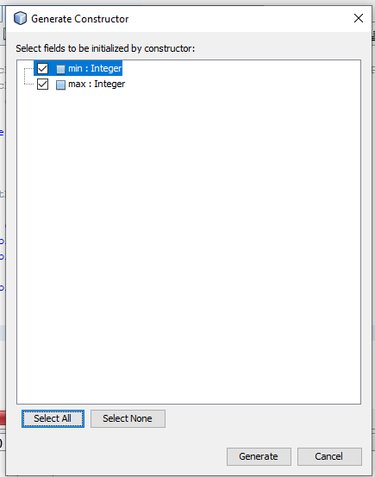

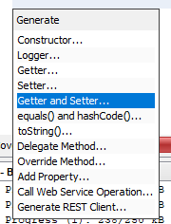

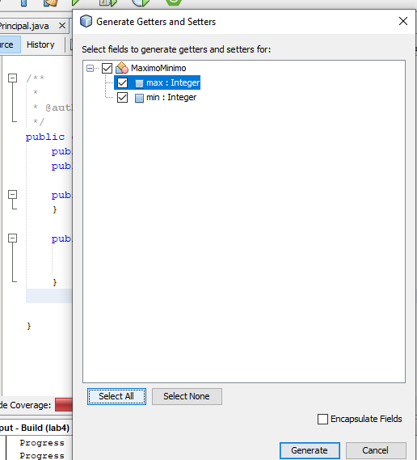

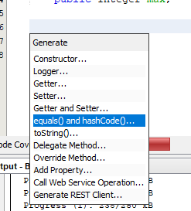

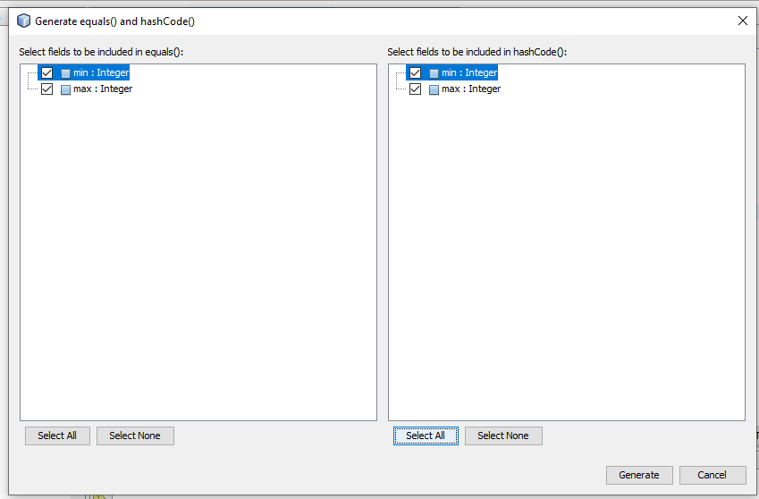

En el service

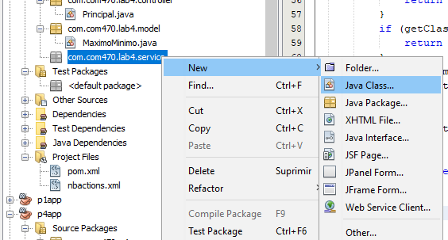

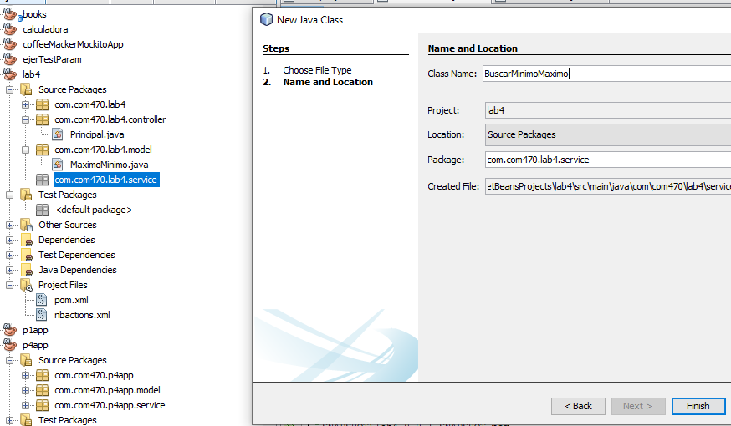

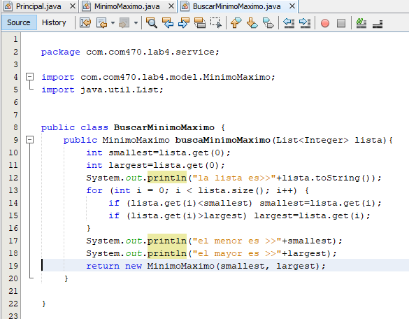

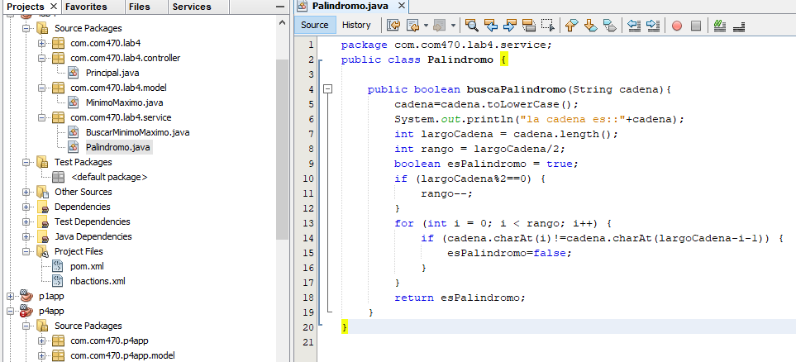

Realizar el test

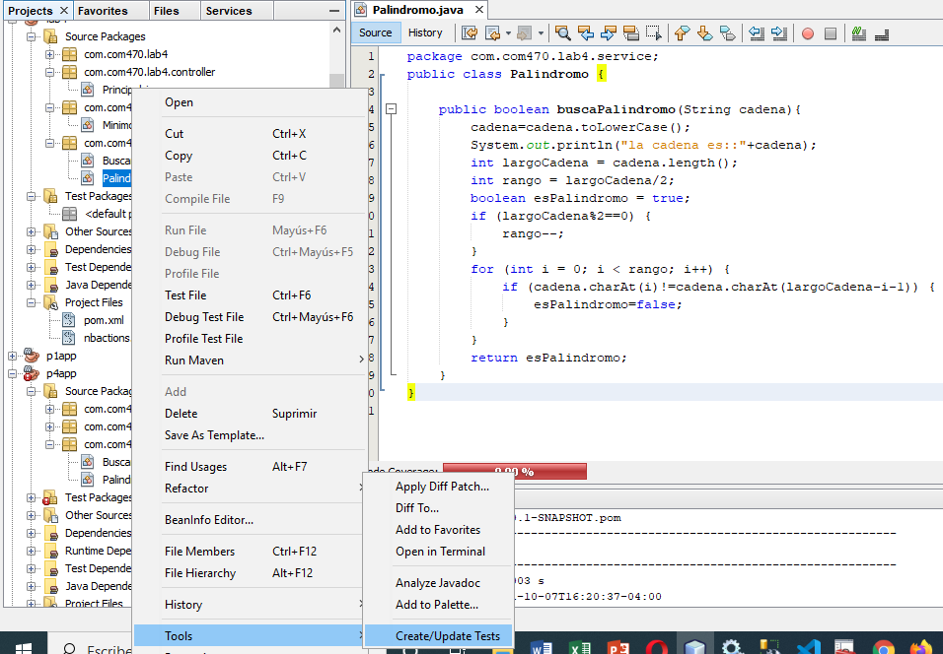

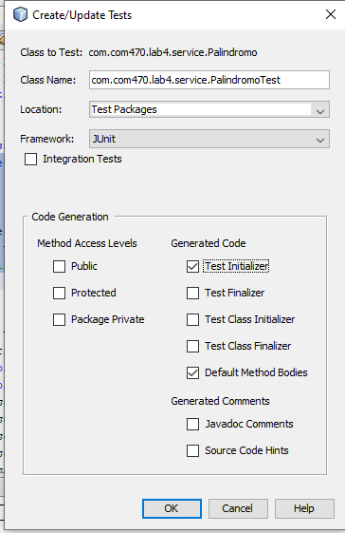

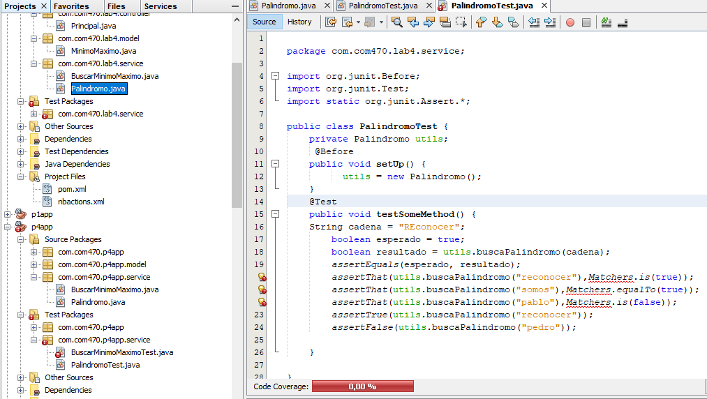

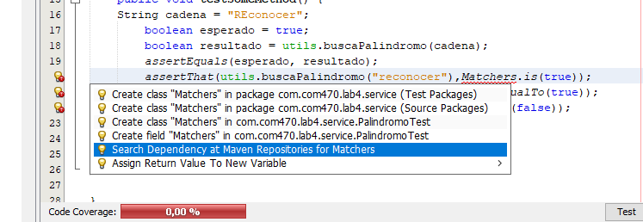

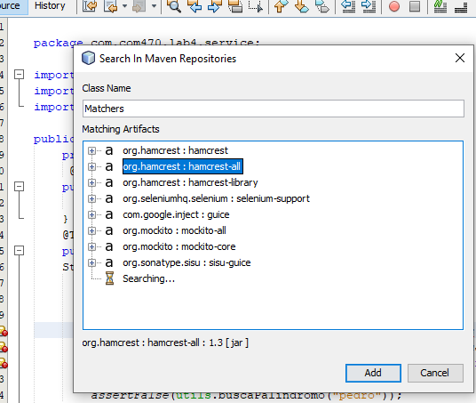

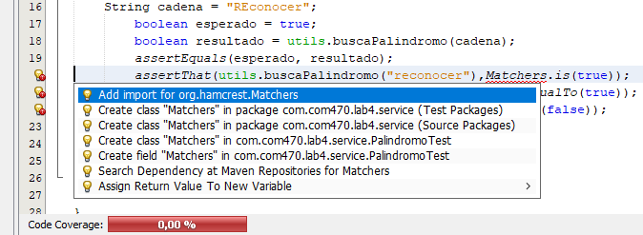

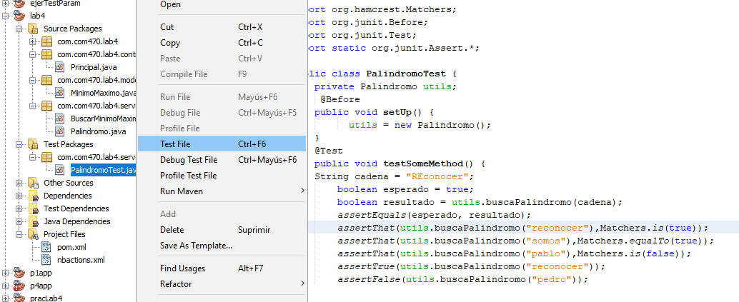

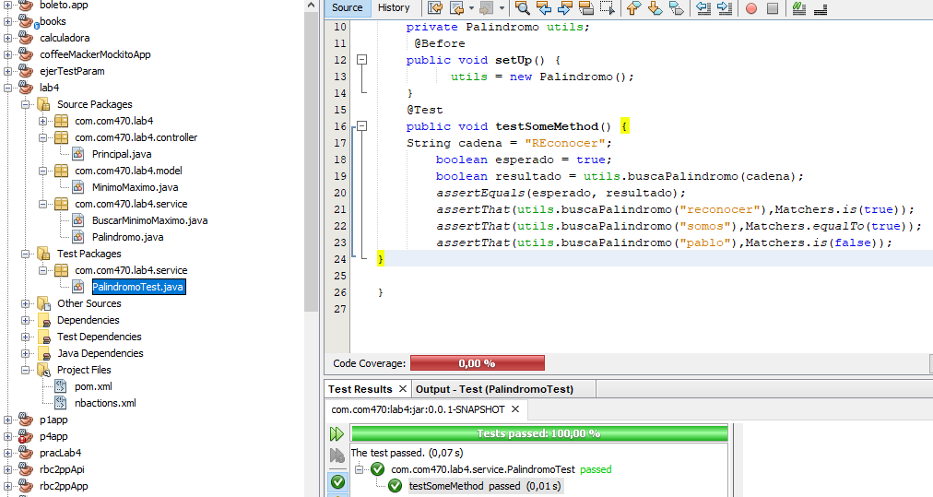

Lo mismo para el Test BuscarMinimoMaximo

Verificar con la COBERTURA

